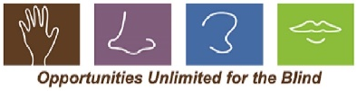
Non-Custodial Parent Permission Form to Attend OUB Camps

Only non-custodial parents who have legal rights to have visitation with their children are required to sign this form.

Camper Information
Name:
Address:
Home Phone:

Camp attending:
Dates of camp:

Non-Custodial Parent Information
Name:
Address:
Home Phone:
Cell Phone:

I , give permission for my child to attend OUB Camps 2019.

Signature: Date:

