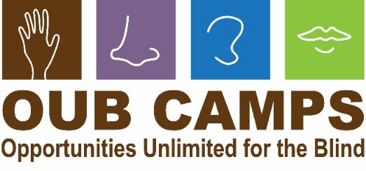
Opportunities Unlimited for the Blind’s mission: building life skills, self-confidence and independence for children and young adults who are blind or have low vision.
Opportunities Unlimited for the Blind is a 501(c)3 non-profit organization

WISH LIST
December 2019

Opportunities Unlimited for the Blind is a 501c3 non-profit organization. We treasure your support!

This list is getting smaller every year, thanks to many individuals who have helped us reach our goals and supply our camp with the tools we need to help our campers be successful!

Important needs you can help fill!
- Culligan water service for 6 weeks – we have switched to using refillable water bottles instead of bottled water (camp water is safe but not very palatable!)
- Funds for refillable water bottles
- Funds for staff salaries - they earn it! And your donation is tax-deductible
- 12-Passenger van in good condition.

General Camp Needs:
- Paper products (toilet paper, paper towels, the brown towels on rolls for dispensers, kleenex)
- Kitchen sanitizer wipes, such as Clorox
- Hand sanitizer and wipes
- Van clean up kits for each van (3) – whisk brooms, paper towels, antiseptic wipes, hand sanitizer, air fresheners, etc.
- Small kitchen appliances (used is fine): mixers, food processors, microwaves (we have lots of toasters and blenders now – thank you!)
- Silicone, felt, or plastic furniture “dots” to use for marking kitchen tools, etc
- Large stainless steel mixing spoons, rubber scrapers, etc.
- Pantry staples, like pasta, tomato sauce, juice boxes, muffin mixes, etc
- Gift cards Costco, Meijer and Gordon Food Service for general groceries
- Gift cards to Home Depot, sporting goods stores, Lowes, Meijer, Bed, Bath and Beyond, Michaels, etc (to purchase kitchen tools, crafts, and replacement tents and tent poles!)
- Craft Supplies: Washable markers, crayons, glue dots, duct tape, wooden beads, feathers, wire, wire cutters, leather embossing kits, leather laces, air dry modeling dough, small flower pots, quick dry craft glue, art paper, yarn, string, etc! Feel free to clean out your craft cupboard at home!

Adventure Trip Needs:
- Tool kit for camping including duct tape, heavy duty wire, zip ties, bungee cords, hammer, etc.
- Small battery powered fans, flashlights, extra batteries (C and D size)

Office Needs:
- Braille labeler and clear label tape
- Printer paper
- Office supplies (pens, pencils, markers, blank address labels)

We encourage every camper to bring at least one small item to donate!

Thanks!!!

What one cannot do alone, we can do together!

Your gift may be tax deductible.

Questions? Delivery issues? Contact:

Gwen Botting, Executive Director
Opportunities Unlimited for the Blind
4175 Westbrook Road, Ionia MI 48846
gwen@oubmichigan.org
989-855-2430 or 616-755-2221 (c)

www.oubmichigan.org



