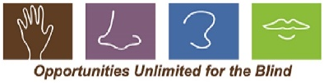
OUB Staff/ Volunteer Liability Release Form

I, , employee or volunteer of Opportunities Unlimited for the Blind, do hereby release from liability, waive, indemnify, save, and hold harmless the board members and other employees and volunteers of Opportunities Unlimited for the Blind, and participating facilities and hold that this agreement is intended to be broad and inclusive as is permitted by the law of the State of Michigan.
In addition, the program has my permission to secure emergency medical and/or emergency surgical treatment for me in the event that I am unresponsive. Non-emergency medical treatment is not included in this authorization.
This form covers one year from the date given below.

Employee’s or Volunteer’s Signature Date

Staff/ Volunteer Photo Release

The occasion may occur when you will be included in a photograph and/or video which we may wish to use for publicity purposes related to OUB programming, fundraising and support. It is necessary for us to have approval on file allowing us to use your picture for video footage to assist in providing information during various presentations throughout the state. The methods of displaying picture(s)/video(s) may include social media, websites, and other types of electronic publication and along with the use of print publications for programing, fundraising, and support.
Please indicate your decision by checking below.
This form covers one year from date printed below.

Employee’s or Volunteer’s Name:

I give OUB permission to use my photograph or video footage for publicity, fundraising and programming support.

I DO NOT give OUB permission to use my photograph or video footage.

Employee’s or Volunteer’s Signature Date

