Opportunities Unlimited for the Blind
Presents:
Cooking Up the Holidays
Virtual Version
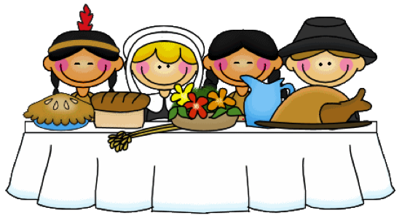
This Photo by Unknown Author is licensed under CC BY-NC-ND
Thanksgiving - November 14th 11 AM
Mashed Potatoes, Green Bean Casserole and Pumpkin Puffs

Christmas Holiday Season - December 19th 11 AM
Cookies and Ornaments

Led by OUB Staff who are blind or low vision
To Register or with questions: email Gwen Botting, gwen@oubmichigan.org
THIS EVENT IS FREE! Some materials are required.

